Detector-Plane Causality in Quantum Measurement: A Benchmark Framework for Measurement Integrity and Control
Srikar R
Independent Researcher
Srinivasa Residency, Flat.No.302,
Green Hills Colony, Road.No.2,
Hyderabad - 500102, Telangana,India
Email - r.srikar.30@gmail.com
*Revisions relative to the previous submission are indicated in blue text.

Abstract
Quantum measurement experiments rely on detector systems whose physical, electronic, and computational properties determine which correlations are preserved during measurement. While interference is often described in terms of statistical accumulation or observer-dependent collapse, experimental outcomes are constrained by structured detector pipelines that impose irreversible transformations on measured signals.
We introduce the Quantum Measurement Stack (QMS), a causally ordered instrumentation framework that localizes irreversible information loss at the detector plane, defined as the combined detector material, front-end electronics, digitization, firmware, and software readout. Using this framework, we define QMCTB-01, a detector-plane benchmark based on a near-field double-slit configuration.
Wave-optics simulations with identical photon statistics show that interference visibility is determined by detector-plane coherence preservation rather than photon accumulation. Intensity-only detection suppresses interference irreversibly, while correlation-preserving detection yields stable fringe geometry independent of frame count.
These results establish detector-plane coherence fidelity as a measurable instrumentation property and provide a practical benchmark for diagnosing and controlling quantum measurement systems.

Introduction
Quantum interference experiments, particularly the double-slit configuration, are widely used in both foundational studies and applied quantum optics. In pedagogical descriptions, interference patterns are often presented as emerging through the accumulation of detection events, as demonstrated in canonical single-particle interference experiments [8,9]. In experimental practice, however, interference visibility depends critically on detector system properties.
Modern quantum experiments employ detector pipelines composed of sensor materials, analog electronics, digitization hardware, firmware, and software reconstruction, each of which plays a determinative role in measurement outcomes [1–4]. Once correlations are lost at these stages, they cannot be recovered through integration or post-processing, consistent with established limits in information theory and digital signal processing [5–7].
Despite this, detector behavior is often treated implicitly. For instrumentation-focused investigations, a systematic framework is required to identify, localize, and benchmark detector-induced information loss.
Here, quantum measurement is treated explicitly as an instrumentation and signal-processing problem. We introduce the Quantum Measurement Stack (QMS), which decomposes a quantum experiment into causally ordered operational layers and localizes the effective measurement boundary at the detector plane. Using this framework, we define the QMCTB-01 benchmark and demonstrate its application using a near-field double-slit configuration.
This work does not propose a new interpretation of quantum mechanics. Instead, it treats quantum measurement explicitly as an instrumentation and signal-processing problem, focusing on how detector-plane processing constrains observable correlations. The novelty lies in formalizing detector-plane coherence preservation as a benchmarkable instrumentation property, independent of photon statistics, observer effects, or post-processing.

Quantum Measurement Stack
The Quantum Measurement Stack decomposes a quantum experiment into the following ordered layers:
- Field excitation and imprint formation
- Detector-plane imaging
- Data acquisition (DAQ) integrity
- Quantum diagnostics
- Quantum control system (QCS)
A defining principle of the QMS is strict causal ordering: information flows downward, and correlations destroyed at any layer cannot be recovered by subsequent processing, consistent with established limits in signal processing and information theory [5–7].
The QMS is a diagnostic abstraction that formalizes functional roles already present in experimental pipelines and enables targeted identification of irreversible information loss. A schematic illustration of the QMS and detector-plane causality is shown in Fig. 1.

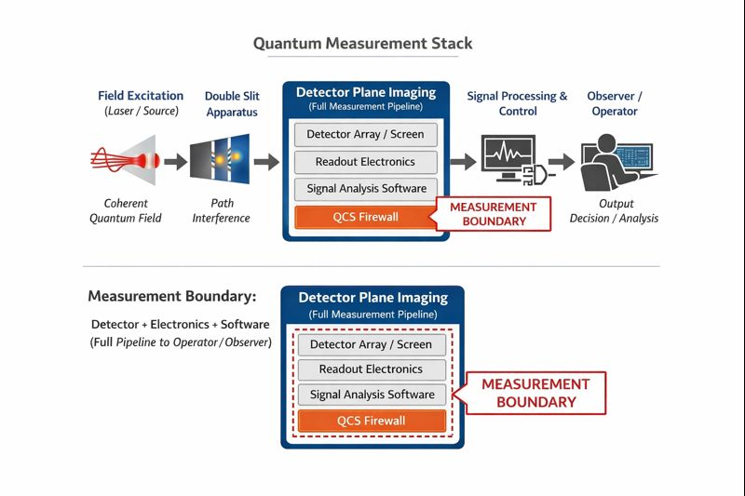

Detector Plane Definition
Within the QMS, the detector plane defines the effective measurement boundary. It includes all subsystems that irreversibly transform measured signals prior to analysis, as is well documented for detector materials and readout electronics [3,4]:
- Detector material (e.g., pixel sensor, photocathode)
- Analog front-end electronics
- Digitization hardware and firmware
- Software readout and reconstruction
Information loss introduced at any of these stages is irreversible within the measurement process. Human observation occurs only after this boundary and plays no causal role in coherence preservation.

QMCTB-01: Detector-Plane Causality Benchmark
QMCTB-01 addresses the operational question:
Is interference visibility determined by photon statistics or by detector-plane coherence preservation?
The benchmark isolates detector-plane behavior by holding excitation, propagation, and photon statistics constant.
A near-field double-slit configuration is evaluated under two detector regimes: intensity-only detection, in which phase correlations are discarded at the detector plane, and correlation-preserving detection, in which phase correlations are retained through the detector pipeline. All other experimental and statistical parameters are identical.

Simulation and Methods
Paraxial wave-optics simulations with Poisson-distributed shot noise are used to emulate photon detection. Detector behavior is modeled explicitly at the detector plane rather than during post-processing.
In intensity-only detection, phase correlations are discarded at the detector plane. In correlation-preserving detection, correlations are retained throughout the detector pipeline. No reconstruction, filtering, or adaptive processing is applied that could recover discarded correlations, consistent with established limits of digital signal processing once information has been irreversibly discarded [6,7].
Detector non-idealities such as dark counts, read noise, and pixel crosstalk are not included. These effects are expected to further degrade correlation preservation experimentally and do not alter the causal structure of the benchmark.
The benchmark is intentionally defined in an idealized regime to isolate detector-plane causality; inclusion of realistic detector non-idealities is expected to further degrade coherence but does not alter the causal structure or conclusions of QMCTB-01.

Results
In the intensity-only detection regime, interference fringes are absent. Increasing frame accumulation reduces noise but does not recover fringe geometry; visibility decreases monotonically toward zero.
In the correlation-preserving detection regime, high-contrast interference fringes are present immediately and remain invariant with frame count. The fringe geometry is established early and does not change with additional accumulation.
Representative results from the two detector regimes are shown in Fig. 2. These results demonstrate that interference visibility is fixed by detector-plane processing and cannot be recovered once correlations are discarded.

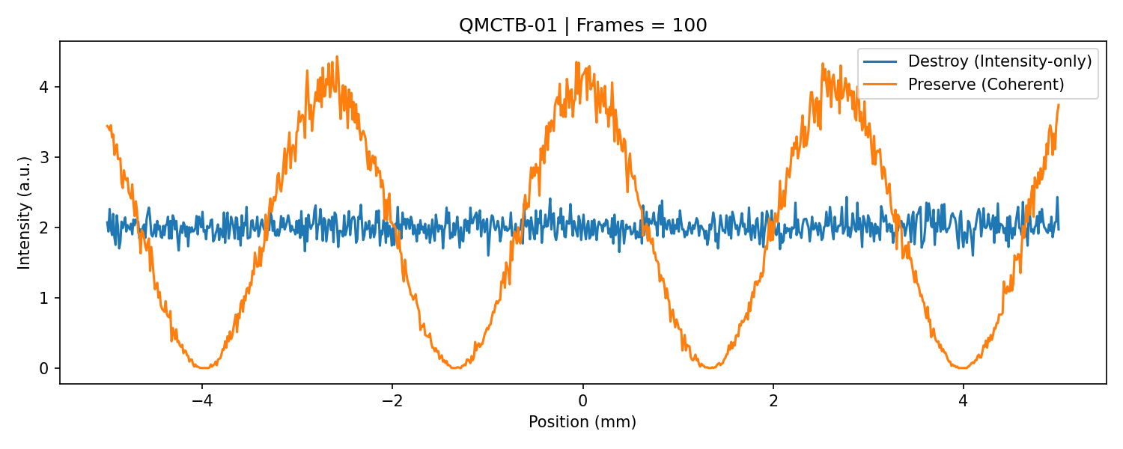

Implications for Measurement and Control
The benchmark supports three instrumentation-level conclusions.
- Irreversible information loss is localized at the detector plane.
- Interference visibility is constrained by detector-plane processing rather than statistical accumulation.
- Measurement integrity can be treated as a controllable hardware parameter.
These conclusions motivate the definition of detector-plane coherence fidelity as a measurable quantity, consistent with established measurement-science practices and uncertainty analysis [10], and support the integration of diagnostics and control through a Quantum Control System.

Conclusion
Quantum interference measurement can be treated as a detector benchmarking and control problem rather than a consequence of statistical accumulation or observation. By defining the detector plane as the measurement boundary and enforcing causal ordering through the Quantum Measurement Stack, this work provides a practical framework for diagnosing and controlling detector-induced coherence loss.
By explicitly separating detector-plane causality from observer-dependent descriptions, the framework provides a measurement-science perspective applicable across quantum optics, solid-state detectors, and hybrid quantum systems.
The QMCTB-01 benchmark enables reproducible evaluation of detector-plane coherence fidelity across detector technologies and experimental platforms.

Data Availability
Simulation code and benchmark artifacts are available in accordance with FAIR data management principles [11] at:
- https://github.com/srikarr20/quantum-measurement-stack
- https://doi.org/10.5281/zenodo.18075090

References
[1] M. D. Eisaman, J. Fan, A. Migdall, and S. V. Polyakov,
"Invited review article: Single-photon sources and detectors,”
Rev. Sci. Instrum. 82, 071101 (2011).
[2] R. H. Hadfield,
"Single-photon detectors for optical quantum information applications,”
Nat. Photonics 3, 696–705 (2009).
[3] J. R. Janesick,
Scientific Charge-Coupled Devices,
SPIE Press, Bellingham, WA (2001).
[4] A. Rogalski,
"Infrared detectors: status and trends,”
Prog. Quantum Electron. 27, 59–210 (2003).
[5] C. E. Shannon,
"A mathematical theory of communication,”
Bell Syst. Tech. J. 27, 379–423 (1948).
[6] R. G. Lyons,
Understanding Digital Signal Processing,
3rd ed., Prentice Hall (2010).
[7] J. S. Bendat and A. G. Piersol,
Random Data: Analysis and Measurement Procedures,
4th ed., Wiley (2010).
[8] A. Tonomura et al.,
"Demonstration of single-electron buildup of an interference pattern,”
Am. J. Phys. 57, 117–120 (1989).
[9] R. Bach et al.,
"Controlled double-slit electron diffraction,”
New J. Phys. 15, 033018 (2013).
[10] B. N. Taylor and C. E. Kuyatt,
Guidelines for Evaluating and Expressing the Uncertainty of NIST Measurement Results,
NIST Technical Note 1297 (1994).
[11] M. D. Wilkinson et al.,
"The FAIR Guiding Principles for scientific data management and stewardship,”
Sci. Data 3, 160018 (2016).

Figure Descriptions
Figure 1.

Figure 1. Canonical Quantum Measurement Stack illustrating causal ordering and localization of irreversible information loss. The detector plane defines the effective measurement boundary and includes the detector material, analog front-end electronics, digitization, firmware, and software readout. Information flows downward through the stack, and correlations discarded at any layer cannot be recovered by subsequent processing. Human observation occurs only after the detector plane and does not influence coherence preservation.

Figure 2.

Figure 2. QMCTB-01 detector-plane causality benchmark results for a near-field double-slit configuration under identical excitation, propagation, and photon statistics.
- Intensity-only detection, in which phase correlations are discarded at the detector plane, yields no stable interference fringes; increasing frame accumulation reduces noise without recovering fringe geometry.
- Correlation-preserving detection retains phase correlations through the detector pipeline and produces high-contrast interference fringes that are established immediately and remain invariant with frame count.

